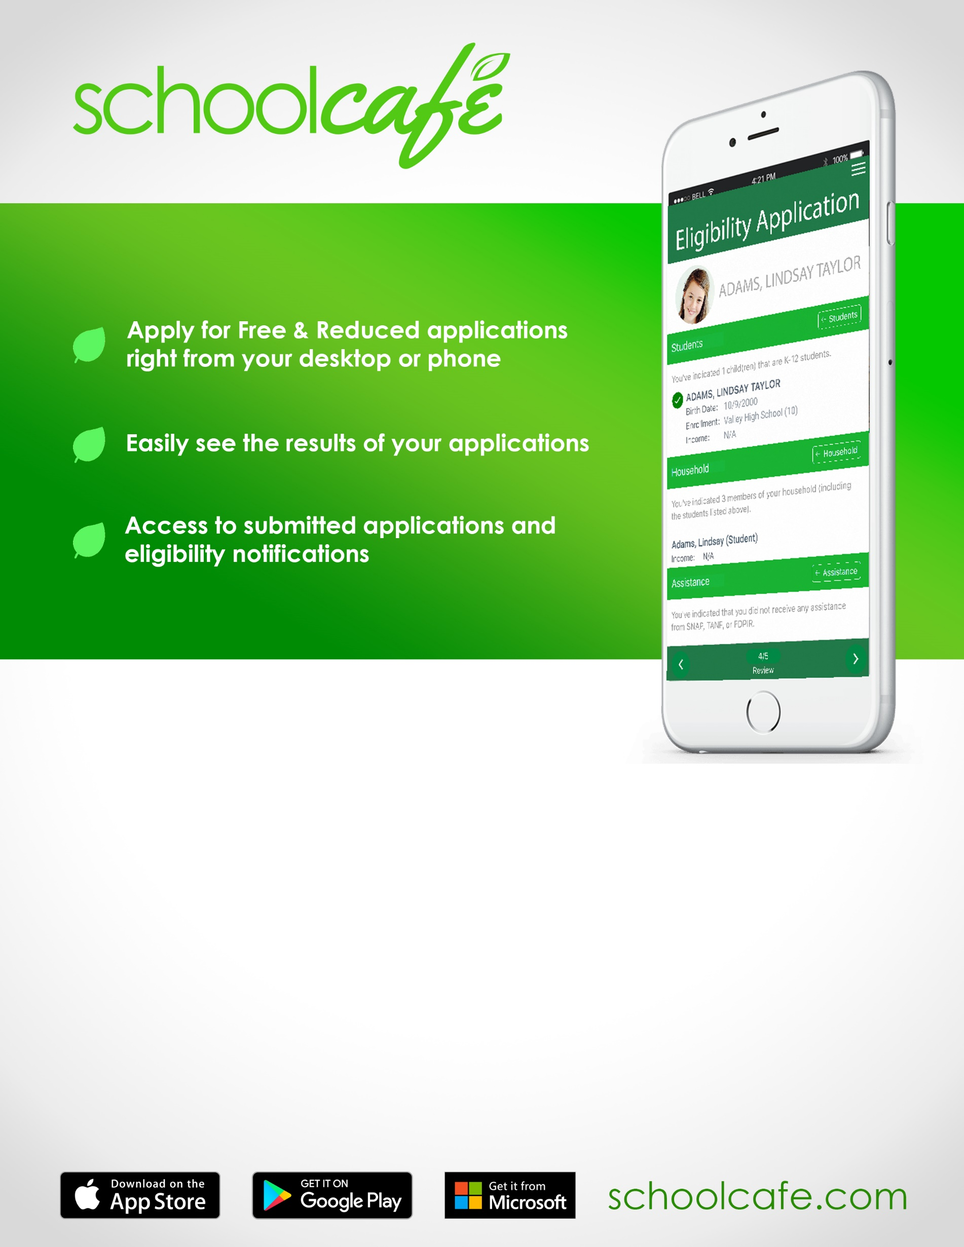

[](http://www.google.com/url?url=http://www.healthyeating.org/Schools/Tips-Trends/Article-Viewer/Article/263/new-school-lunch-meal-pattern.aspx&rct=j&frm=1&q=&esrc=s&sa=U&ei=CkLEU8zwI86gyASv6oHYAw&ved=0CCAQ9QEwBQ&usg=AFQjCNGQZvoLZq_M4uMAvq7BVVctesmoJA)  [](http://www.google.com/url?url=http://www.healthyeating.org/Schools/Tips-Trends/Article-Viewer/Article/263/new-school-lunch-meal-pattern.aspx&rct=j&frm=1&q=&esrc=s&sa=U&ei=CkLEU8zwI86gyASv6oHYAw&ved=0CCAQ9QEwBQ&usg=AFQjCNGQZvoLZq_M4uMAvq7BVVctesmoJA)

**Online Free and Reduced Meal Applications**

* It’s easy and takes less time than paper
* Built-in HELP and Instructions within the online form
* Automated Income Calculation
* Digital Signatures
* Try it today…. [schoolcafe.com](http://www.schoolcafe.com)
* To retrieve Username and/or Password Contact 1-855-729-2328

This institution is an equal opportunity provider.

**\*\*\* Include email address on Application**